# Ultrasonic Sensor

# Introduction

The purpose of this document is to describe the Ultrasonic Sensor block of the Wearable Sensor for the Blind ECE Senior Capstone Project to other engineers with enough detail such that they would be able to reproduce and test this block using only this document as reference. The Ultrasonic Sensor block is implemented using a JSN-SR04T waterproof ultrasonic module. Included in this document are an overview of the block, a schematic and wiring diagram, the properties of the interfaces with the other blocks in the system and testing procedures for each, and reasoning for why this design is the best solution for this block.

# Block Overview

The Ultrasonic Sensor block will provide the distance to the nearest object in the direction that the user’s head is pointing to the system, which will use that information to set the system haptic feedback module that will convey that distance information to the user. The measurements taken need to be fast and accurate, so that the user can quickly and confidently navigate around obstacles in their environment. The sensor will determine the Fig. 1 below shows the black box diagram of the system. *otsd_ultrsnc_snsr_envin* represents the environmental input to this block, namely the distance to the nearest object. *ultrsnc_snsr_snsr_cntrllr_data* represents the sensor data link to the microcontroller. And finally, *pwr_spply_ultrsnc_snsr_dcpwr* represents the connection to the power supply, which is regulated to 5V, and should draw about 5mA during measurements. Sean Sylwester completed this block.

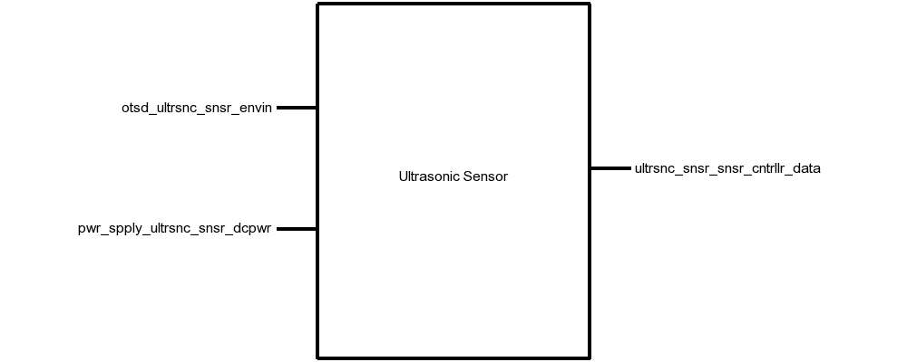

Fig. . Black Box Diagram of Ultrasonic Sensor Block

Table . Display Block Interfaces And Properties

| Interface | Properties |
| --- | --- |
| *otsd_ultrsnc_snsr_envin* | 1. Other: Accuracy: 10cm 2. Other: Angle: 37.5° 3. Other: Range: 20-500cm |
| *ultrsnc_snsr_snsr_cntrllr_data* | 1. Messages: Object Distance 2. Other: Measurement Time: <38ms 3. Other: Pulse Voltage: 3.3V 4. Protocol: TTL |
| *pwr_spply_ultrsnc_snsr_dcpwr* | 1. Inominal: 5mA ± 10% 2. Ipeak: 30mA 3. Vmax: 5.5V 4. Vmin: 3V |

# Verification

This section details the testing procedures to verify every property listed in Table I. All tests must be passed successfully before this block will be integrated into the rest of the system.

## Measurement Testing

This test will verify the measurement requirements for this block on the *otsd_ultrsnc_snsr_envin* interface.

1. Connect the JSN-SR04T ultrasonic sensor to a DC power supply set to 3.3V via the *pwr_spply_ultrsnc_snsr_dcpwr* interface.
2. Connect the JSN-SR04T Echo and Trigger pins to a microcontroller.
3. Load a test program on the microcontroller that continuously triggers a measurement with a 3.3V pulse, reads the sensor data with a TTL protocol, and prints the result to a computer.
4. Place an object 20cm directly in front of the sensor and note if the sensor detects the object.
5. Place an object 500cm directly in front of the sensor and note if the sensor detects the object.
6. Place an object 100cm away, and 75cm off-center (37.5°) and note if the sensor detects the object.
7. Place an object 100cm directly in front of the sensor and note if the sensor measurement is within 10cm of 100cm.

PASS: If the measurement completes in less than 38ms, objects in steps 4, 5, and 6 were detected, and the object in step 7 was detected within 10cm.

[Link to Video](https://drive.google.com/open?id=1ZqxbQ-ia4OiUPHisv6PiKTbCvmjG8xuT)

*Power Testing*

This test will verify the power requirements for this block on the *pwr_spply_ultrsnc_snsr_dcpwr* interface.

1. Connect the JSN-SR04T ultrasonic sensor to a DC power supply set to 5.5V via the *pwr_spply_ultrsnc_snsr_dcpwr* interface.
2. Connect the JSN-SR04T Echo and Trigger pins to a microcontroller.
3. Trigger a measurement by pulling the Trigger pin to 3.3V for 10µs.
4. Note the current displayed on the DC power supply during a measurement, and during idle.
5. Repeat steps 1-4 with the DC power supply set to 3V.

PASS: If the current never exceeds 30mA, a pulse on the Echo pin is returned with the 3V and 5.5V supplies.

[Link to Video](https://drive.google.com/open?id=1ZqxbQ-ia4OiUPHisv6PiKTbCvmjG8xuT)

# Design

The schematic in Fig. 2 presents this wiring diagram for the JSN-SR04T sensor used in this block, including the interfaces of this block to the rest of the system. The timing diagram in Fig. 3 shows the input and output data from the block. Table II provides validation for each of the properties listed in Table I using the JSN-SR04T datasheet.

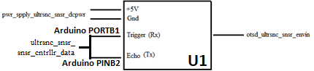

Fig. . Wiring Diagram for the Ultrasonic Module Block

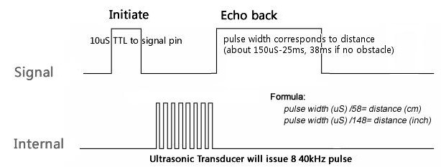

Fig. . Measurement Timing Diagram for the Ultrasonic Module Block

# Design Validation

For this block, the JSN-SR04T ultrasonic sensor was used. This sensor was chosen because it fits the water resistance, measurement distance, accuracy, and angle of detection metrics required of the Ultrasonic Sensor Block. Table II below validates each property listed in Table I. Note that the sensor used in the JSN-SR04 is identical to the one used in the HC-SR04. Neither of these have a datasheet, but the HC-SR04 has a reference document with enough information to validate these properties.

Table . Interface Property Validation For The Ultrasonic Sensor Block

| Property | Validation |
| --- | --- |
| *pwr_spply_ultrsnc_snsr_dcpwr* | |
| Min Voltage: 3 V | The HC-SR04 datasheet says that the minimum supply voltage is 3 V [13] |
| Max Voltage: 5.5 V | The HC-SR04 datasheet says that the maximum supply voltage is 5.5 V [13] |
| Nominal Current: 5mA | The HC-SR04 datasheet says that the nominal working current nominal is <8mA [13] |
| Peak Current: 30mA | The HC-SR04 datasheet says that the quiescent current is less than 2 mA [13] |
| *otsd_ultrsnc_snsr_envin* | |
| Range: 20 cm - 500cm | The HC-SR04 datasheet says that the distance range is 20-500cm [13] |
| Range accuracy: 10cm | The HC-SR04 datasheet says that the distance measurement is accurate to ±0.3cm [13] |
| Angle: 15° | The HC-SR04 datasheet says that angle of the ultrasonic is at least 15° [13] |
| *ultrsnc_snsr_snsr_cntrllr_data* | |
| Pulse Protocol: TTL | The HC-SR04 datasheet says that a Time-to-Life (TTL) signal is used to encode the distance measurement [13] |
| Other: Measurement Time: <38ms | The HC-SR04 datasheet says that the width of the TTL signal is 150µs to 25ms, and 38ms if no object is detected [13] |
| Pulse Voltage: 5 V | The HC-SR04 datasheet says that the Echo and Trigger pins function with a 3.3V pulse signal [13] |
| Messages: Sensor Data | The HC-SR04 datasheet says that a Time-to-Life (TTL) signal is used to encode the distance measurement [13] |

# Bill of Materials

Table . Bill of Materials for the Ultrasonic Sensor Block

| Reference Designator | Description | Manufacturer | Manufacturer Part Number | Suppliers | Quantity | Price |
| --- | --- | --- | --- | --- | --- | --- |
| U1 | Ultrasonic Sensor | JSN | JSN-SR04T | Digi-Key | 1 | $15.39 |

1. ITeadStudio, “Ultrasonic Ranging Module : HC-SR04,” HC-SR04 datasheet, Mar. 2011